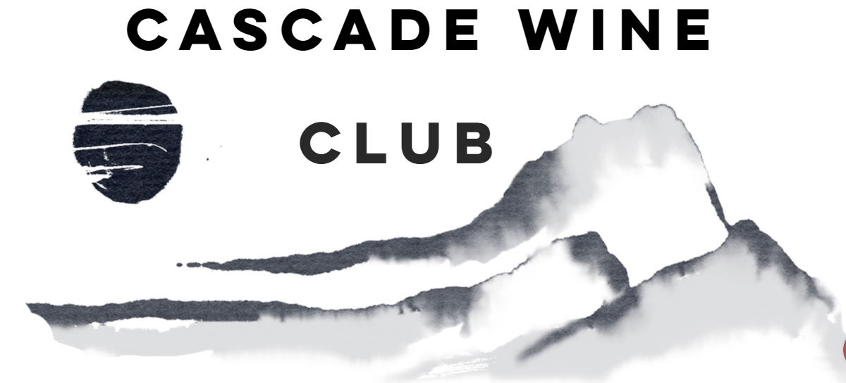

Our wine club provides wine enthusiast the opportunity to explore the wines of the Northwest region, learn about international varietals, value a wine that appreciates over time and experience it with family and friends. We offer 3 tiers of membership levels to match your taste and preferences.
Cascade Cellar  - 4 shipments per year with 4 bottles selected  - 15% savings on 12+ bottles  - No cost to join membership  - Preferred delivery and shipping  - Access to wine library  - Membership only private events  - 3 guest passes to events | Cascade Collector  - 4 shipments per year with 6 bottles selected  - 20% savings on 12+ bottles  - Preferred delivery and shipping  - No cost to join membership  - Access to wine library  - Membership only private events  - 5 guest passes to events | Cascade Central  - 4 Custom shipments per year with 12 bottles selected  - 20% savings 8+ bottles  - Preferred delivery and shipping  - No cost to join membership  - Access to wine library  - Membership only private events  - Unlimited guests passes to events

Name : | CC Type:
Address : | CC #:
City : | Expiration Date:
Email :
Phone :

Yes I, xxxxxxxxxxxxxxxxxxxxxxxxxxxxxxxx would like to join the Cascade Wine Club. I understand my credit card will be charged the price of the wine and the shipping charges on approximately every third month. I understand I am not being charged for a wine membership club. I will be notified via email that my wine is ready for pick – up or will be shipped. I may cancel the wine subscription by submitting a 30 day cancellation notice. The Cascade Wine Club is not responsible for any non – sufficient fun charges to your accounts. Signature xxxxxxxxxxxxxxxxxxxxxxxxxxxxxxxxxxxxxx Date xxxxxxxxxxxxxxxx

